

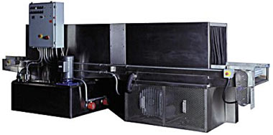

HARRIS TOOL COMPANY MODEL NO. PTW-3 PASS THROUGH WASHER WITH FOLLOWING MACHINE SPECIFICATIONS:

- TOGGLE SWITCH OPERATED STAINLESS DISC TYPE OIL SKIMMER
- 18KW ELECTRIC HEATER
- TANK DEBRIS SCREEN BASKET(180 SQ. IN.)
- 7.5 HP CAST IRON VERTICAL SEALESS PUMP W/SCREEN(150 GPM @ 55 PSIG)
- THERMOCOUPLED PROCESS HEAT CONTROLLER W/ DIGITAL READOUT
- 62 SPRAY JET NOZZLES
- 220 GALLON CLEANING SOLUTION SLOPED TANK
- LOW WATER SHUT-OFF SWITCH
- 500 LB. LOAD CAPACITY
- 19” INSIDE LOAD HEIGHT X 24” CONVEYOR WIDTH OPENING W/ NEOPRENE CURTAINS & BAFFLE SEAL
- 1/4 HP SPROCKET/CHAIN DRIVEN CONVEYOR
- 0-15 FT./MIN. CONVEYOR ADJUSTABLE SPEED RATE
- 240/480/60/3 ELECTRICAL CONTROL PANEL(PLEASE SPECIFY VOLTAGE)
- EASY REMOVEABLE ACCESS PANELS FOR NOZZLE SERVICE
- 10 GAUGE TANK/12 GAUGE DOOR & CABINET STEEL PLATE MATERIAL
- 6” DIA. CABINET VENT AND STEAM HOOD
- 72” OVERALL HEIGHT
- 60”W X 150”L FLOOR SPACE REQUIRED
- FRAMEWORK DESIGNED FOR PORTABILITY
- PRECAUTION BLUE PAINT
- 2500 LBS. SHIPPING WT.

